**PDR of electronics used in the rocketry –**

1. **7Semi BMP581 Barometric Pressure & Altitude Sensor Breakout**

The 7Semi BMP581 Barometric Pressure & Altitude Sensor Breakout provides ultra-precise pressure and temperature measurements with I2C and SPI connectivity, low power modes, and customizable performance for your sensing projects.

Exceptional Accuracy & Resolution:

* Pressure accuracy of ±0.5hPa across the sensing range.
* Resolution down to 1/64Pa, offering precise barometric and altitude data.

Low Power Consumption:

* Deep Standby mode consumes just 1.5µA, ideal for power-sensitive applications.
* Normal operating mode draws only 260µA during measurements.

Wide Sensing Range & High Data Rates:

* Pressure sensing range of 30 to 125kPa.
* Output data rates up to 622Hz for fast, real-time data processing.

Programmable Features for Customization:

* Configurable oversampling, FIFO buffer, and low pass filtering for tailored performance.
* Includes 6-bytes of non-volatile memory for user-specific data.

Cost- 796

1. **7Semi ICM-20948 9DoF IMU Breakout**

The 7Semi ICM-20948 9DoF IMU Breakout board offers state-of-the-art motion tracking capabilities with the world's lowest-power 9-axis MEMS MotionTracking device. Ideal for smartphones, tablets, and wearable sensors, this breakout board features a Digital Motion Processor (DMP) that enhances performance by offloading computation from sensors, ensuring optimal efficiency. With its compact design, versatile communication options, and easy integration with your projects, this IMU breakout board is a top choice for developers seeking precision and reliability.

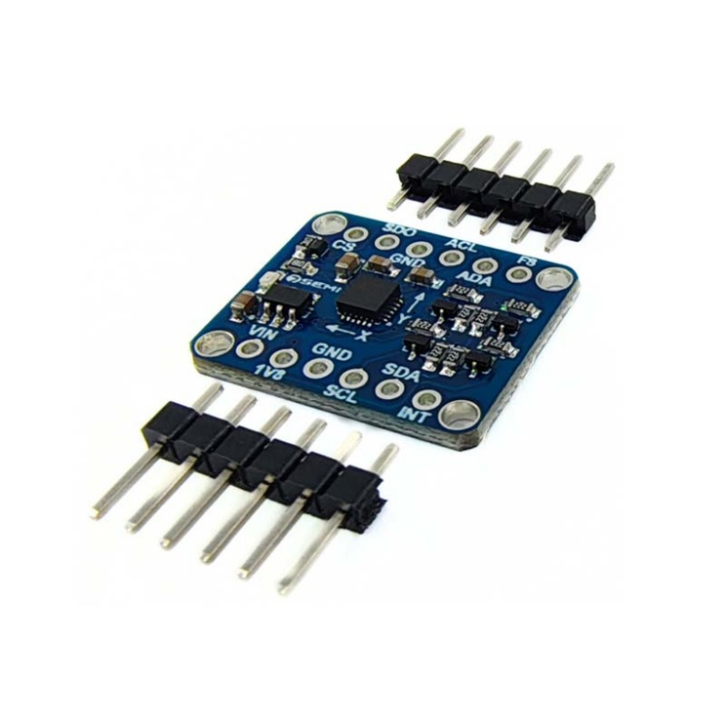

**Key Features:**

* **Comprehensive 9-Axis Motion Tracking:** Triple-axis gyroscope, accelerometer, and magnetometer with multiple programmable ranges.
* **Efficient Digital Motion Processor (DMP):** Offloads computation to ensure smooth and accurate motion tracking.
* **Versatile Communication Interfaces:** Supports I2C and SPI, with up to 7 MHz for SPI communication.
* **Wide Supply Voltage Range:** Operates efficiently between 1.95 V to 3.6 V.
* **Compact and User-Friendly Design:** Breakout board with 0.1"-spaced pins for easy breadboard use, and clearly labeled I2C/SPI pins for seamless integration.

Price- 860

1. **Zigbee XBee Module S2C**

Zigbee is a low-power wireless communication protocol, useful for real-time telemetry in the rocket. It can transmit sensor data such as altitude, temperature, and position back to a ground station. Its mesh network capability allows robust communication even in complex environments with obstacles.

<https://www.mouser.com/datasheet/2/111/ds_xbee-3-zigbee-3-1288823.pdf?srsltid=AfmBOor4w-LmduoaULaoqwj6U_CsMo1S1_4KRDPPBTNJZtvxSWnP_zEg> –datasheet

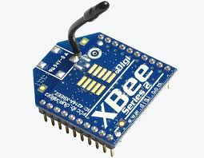

* **Frequency Range**: 2.4 GHz (global), 868 MHz (Europe), and 915 MHz (North America)
* **Data Rate**: Up to 250 kbps
* **Transmission Range**: Typically, up to 100 meters indoors (depends on the environment).up to 2 miles in outdoors.
* **Topology**: Supports star, tree, and mesh network configurations
* **Power Consumption**: Low power consumption, ideal for battery-operated devices
* **Protocol Standard**: IEEE 802.15.4

Price -2000 (2)

1. **Bharat Pi Node Wi-Fi with ESP32, SD Card**: Quad-core ARM Cortex-A72 (64-bit)

* **ESP32 Bit microcontroller – ESP32 Wroom**
* **Memory – 4MB**
* 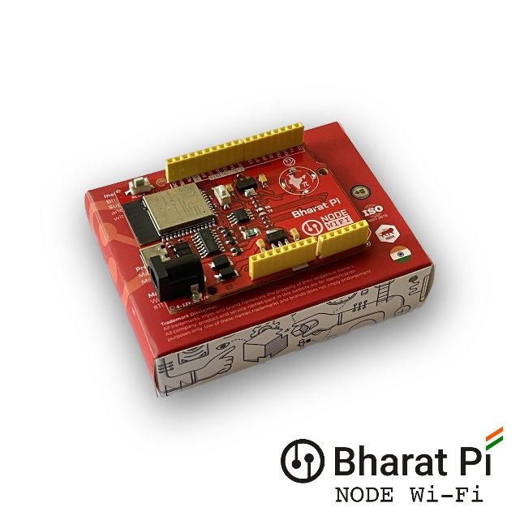**Storage – SD Card slot supports upto 64GB**
* **Reverse polarity protection – (Onboard fuse)**
* **USB Type-C connector**

Cost- 1003

1. **NavIC (Navigation with Indian Constellation)**

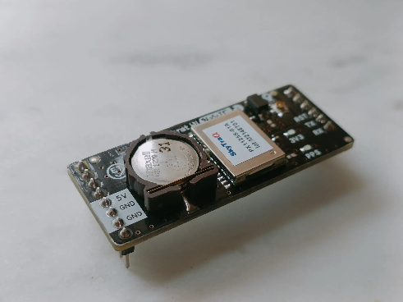NavIC is a satellite-based positioning system designed for regional navigation, offering high accuracy within India and nearby regions. It helps in tracking the rocket’s real-time GPS coordinates and ensuring precise positioning. It can also support recovery operations by locating the rocket after it lands.

<https://bharatpi.net/wp-content/uploads/2024/04/Bharat-Pi-NavIC-Module-Datasheet.pdf> - datasheet

* **Type**: Regional satellite navigation system by India
* **Coverage**: India and up to 1,500 km around the Indian mainland
* **Position Accuracy**: Typically 5-10 meters
* **Signal Frequency**: L5 (1.17645 GHz) and S-band (2.492028 GHz)
* **Applications**: Agriculture, disaster management, vehicle tracking, and navigation​.

Cost- 1770

1. **IRNSS/GPS/GLONASS L1 & L5 Antenna for NavIC GPS Tracker**

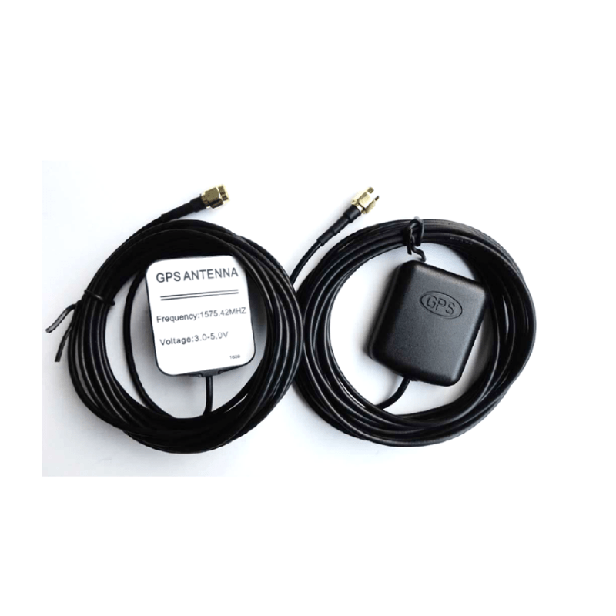

**IRNSS/GPS/GLONASS Antenna with RG174 Cable (L-3Mtr) and SMA (M) St. Connector. L1 + L5 band suitable for NavIC/IRNSS GPS trackers. Quick latching and magnetic mount for ease of use.**

Cost - 885

1. **Voltage Detection Sensor Module 25V**

The Voltage Detection Sensor Module 25V allows you to use the Analog input of a microcontroller to monitor voltages much higher than it capable of sensing.

* 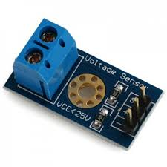**Voltage Detection Range (V):**  0.02445 to 25
* **Dimensions:** 28*14*13 MM
* **Weight:** 5 g

Cost - 17

1. **Temperature Sensor**

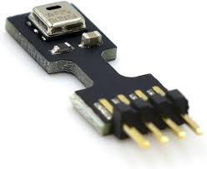The AHT25 Integrated temperature and humidity sensor is equipped with a newly designed ASIC dedicated chip, an improved MEMS semiconductor capacitive humidity sensor element and a standard temperature sensor element, and its performance has reached the industry’s advanced level. The improved new generation temperature and humidity sensor AHT25 has a more stable performance in harsh environments and can maintain good accuracy in a larger measurement range.

* Digital output, I²C interface
* Quick response and strong anti-interference ability
* Relative humidity and temperature output

Cost – 135

1. NRF24L01 2.4GHz PA+LNA SMA Wireless Transceiver Module with Antenna

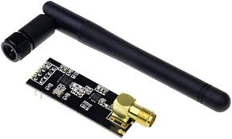Features :-

* It uses 2.4GHz global open ISM band, with license free.
* Transmit power is greater than +20 dBm.
* Support six-channel data reception.
* 2Mbit/s speed makes high-quality VoIP possible
* Multi-frequency points: 125 frequency points meet the needs of multi-point communications and frequency hopping.
* Low cost: integrated with high-speed signal processing parts associated with RF protocol, such as: automatically re-send lost packets and generate acknowledge signal;
* SPI interface facilitates the communication with MCU I/O port.
* Facilitate the development for customers, without development RF part.
* Software programming is fully compatible with NRF24L01 modules.

Price -137 (2)

1. 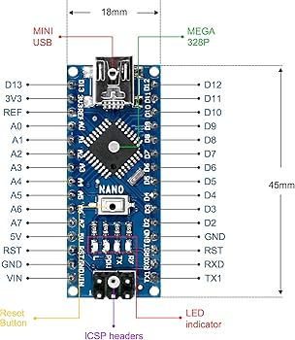Nano CH340 Chip Board

* Operating Voltage (logic level): 5V
* With Soldered Connector
* 8 analog inputs ports: A0 ~ A7
* 14 Digital input / output ports: TX, RX, D2 ~ D13
* 1 pair of TTL level serial transceiver ports RX / TX
* Using Atmel Atmega328P-AU MCU
* There is a bootloader installed in it
* Standard 0.1” spacing DIP (breadboard friendly).
* Manual reset switch.

Price 189 (2)

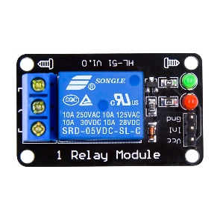

1. 5V 1 Channel Without Light Coupling Relay

* The 8550 transistor drive, driveability.
* A fixed bolt holes for easy installation.
* It has a relay status indicator led Power LED(Green), 8 relay status indicator LED(Red)
* Relay control interface by single-chip IO.
* Low-level suction close, high-level release.
* Easy to use, simple 3 line structure.

Price 80

1. **DS3231 Real Time Clock**

* 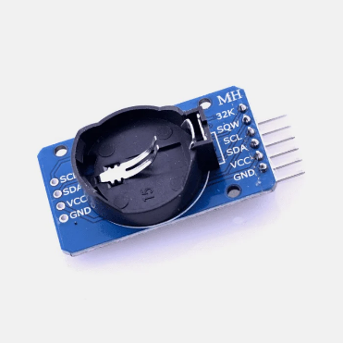Supports 2.2 to 5.5 V for the Real-Time Clock (RTC).
* Equipped with a fast 400kHz I2C interface.
* It's an extremely accurate I2C real-time clock (RTC).
* Has an inbuilt temperature-compensated crystal oscillator (TCXO) and crystal.
* Capable of tracking seconds, minutes, hours, day, date, month, and year.
* Features a built-in 32Kbit EEPROM and a 10-bit temp
* erature sensor with 0.25°C resolution.

1. **Battery for ignition.**

We are planning to ignite the fuel with carbon lid and passing of electricity through it which release high amounts of temperature through temperature.

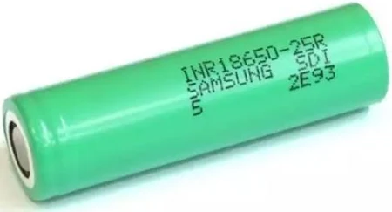Samsung 18650-25R 2500Mah (8C) Li-Ion Battery

1. Brand: SAMSUNG
2. Model: INR 18650 Lithium Battery
3. Battery Capacity: 2500mAh
4. Nominal Voltage: 3.7V
5. Rechargeable: Yes
6. Charging time; Standard charge 3hours/100mA deadline
7. Quick charge: 1hours/100mA deadline (25 °C)
8. **7Semi 3.3 V 2A Mini Buck Converter Breakout - AP61201**

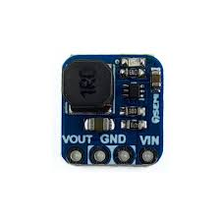The 7Semi 3.3V 2A Mini Buck Converter Breakout features the AP61201, offering efficient power conversion with a 2.3V to 5.5V input range, 3.3V output, and 2A continuous current. Ideal for reliable and stable electronic projects.

* 1. **Power Budget for Rocket Avionics and Ignition System**

**Battery Setup:**

* Battery Type: Two 18650 Lithium-ion cells (7.4V, 2500mAh) in series.
* Nominal Voltage: 7.4V
* Total Energy Storage: 18.5Wh

**Energy Balance and Power Consumption:**

|  |  |  |  |  |  |
| --- | --- | --- | --- | --- | --- |
| Component | Voltage (V) | Current (mA) | Power(W) | Duration  (MIN) | Energy(Wh) |
| |  | | --- | | XBee S2C Module |  |  | | --- | |  | | 3.3V | 65 | 0.215 | 30 | 0.1075 |
| |  | | --- | | Bharat Pi Node (ESP32) |  |  | | --- | |  | | 3.3V | 180 | 0.6 | 30 | 0.3 |
| |  | | --- | | BMP581 (Pressure Sensor) |  |  | | --- | |  | | 3.3V | 1.5 | 0.0045 | 30 | 0.00225 |
| |  | | --- | | ICM-20948 (IMU) |  |  | | --- | |  | | 3.3V | 1.2 | 0.004 | 30 | 0.002 |
| |  | | --- | | AHT25 (Temp & Humidity) |  |  | | --- | |  | | 3.3V | 0.09 | 0.0003 | 30 | 0.00015 |
| |  | | --- | | NavIC GPS Module |  |  | | --- | |  | | |  | | --- | | 3.3V | | 50 | 0.165 | 30 | 0.0825 |
| |  | | --- | | SD Card (Data Logging) |  |  | | --- | |  | | 3.3V | 20 | 0.066 | 30 | 0.033 |
| |  | | --- | | DS3231 RTC Module |  |  | | --- | |  | | 3.3V | 0.3 | 0.001 | 30 | 0.0005 |
| |  | | --- | | Voltage Detection Sensor |  |  | | --- | |  | | |  | | --- | | 3.3V | | 0.2 | 0.00066 | 30 | 0.00033 |
| |  | | --- | | Power Conversion Losses |  |  | | --- | |  | | - |  | ~0.1 | 30 | ~0.05 |

**Total Power Consumption (30 min):**

Total Power: 0.89176 W

Energy:

Energy = 0.89176 W × 0.5 hr = 0.446Wh

Energy=0.89176W×0.5hrs=0.446Wh

**Battery Capacity and Safety Margin:**

The onboard system consumes ~0.446 Wh during a 30-minute flight.

The 18650-battery pack provides 18.5Wh, so it offers a significant margin, ensuring sufficient power for the entire mission.

**2. Ignition System**

Components and Power Consumption:

Battery Setup:

* Igniter Battery: 9V alkaline battery (for igniter e-match).
* Control Battery: 5V power supply for microcontroller (using 18650 Li-ion).

**Energy Balance and Power Consumption:**

**a. Ignition System (Only operates briefly for ignition)**

|  |  |  |  |  |  |
| --- | --- | --- | --- | --- | --- |
| Component | Voltage (V) | Current (mA) | Power(W) | Duration  (MIN) | Energy(Wh) |
| |  | | --- | | E-match Igniter (Momentary) |  |  | | --- | |  | | 9V | 2 | 1.8 | 3 | 0.015 |

**Total Ignition Power Consumption:**

**Power**: 18 W (igniter is momentarily powered by a 9V battery for approximately 3 seconds).

Energy consumed:

**Energy** = 18 W × 3/3600 hours = 0.015 Wh

A standard 9V battery has a capacity of around 500mAh (4.5Wh), so it will easily handle the power requirements of the igniter.

**b. Control System (Arduino Nano and NRF24L01 for remote control)**

|  |  |  |  |  |  |
| --- | --- | --- | --- | --- | --- |
| Component | Voltage (V) | Current (mA) | Power(W) | Duration  (MIN) | Energy(Wh) |
| |  |  |  | | --- | --- | --- | | |  | | --- | | **Arduino Nano** |  |  | | --- | |  | |  |  | | --- | |  | | 5V | 50 | 0.25 | 30 | 0.015 |
| |  | | --- | | **NRF24L01 Module** |  |  | | --- | |  | | 3.3 V | 12 | 0.04 | 30 | 0.02 |
| |  | | --- | | **Relay (Control Igniter)** |  |  | | --- | |  | | 5V | 90 | 0.45 | 30 | 0.225 |

**Total Control Power Consumption:**

**Power**: ~0.74 W

**Energy consumed:**

**Energy** = 0.74 W × 0.5 hours = 0.37 Wh

**Energy**=0.74W×0.5hours=0.37Wh

The control system (Arduino + NRF24L01 + relay) consumes around 0.37 Wh during a 30-minute wait time.

A single 18650 battery (2500mAh, 3.7V) provides 9.25Wh, which is more than sufficient for the control system.